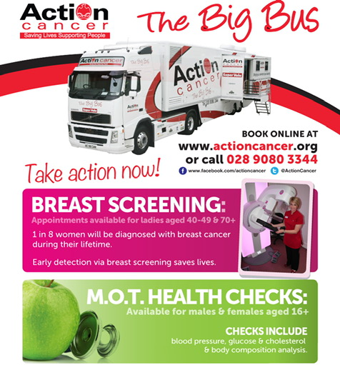
Dear Parent,
As previously advised, I have secured the Action Cancer ‘Big Bus’ for our school on Friday 10th May 2019. Appointments will be available form 9.30 am– 3.20pm. However, there are a limited number of appointments and they must be booked in advance. As you can see from the advert the bus offers both breast screening and MOT health checks. There will only be 24 breast screening appointments and 13 MOT health checks available on the day, therefore I would advise prompt booking to secure a place.
As the bus is booked privately on behalf of the school community, I have been issued with a special code to allow booking access. Please contact me at school to receive the code. Within the booking process you will be asked for your health and social care number. this can be obtained by contacting your GP’s office.
Anyone wishing to book an appointment can do so either by using the online booking service at www.actioncancer.org/appointments or by calling Action Cancer on 028 9080 3344 and selecting Option 1.
Further information regarding both services will be available on both the school website and on our display board in the school foyer. Please take the time to read this information if you are considering making an appointment.
I sincerely hope you will avail of this vital opportunity and would like to thank you all again for your continued support.

Kindest Regards

Clair Waterson

